**#F14-CS**

|  |  |  |
| --- | --- | --- |
| Kingdom of Saudi Arabia  Ministry of Education  Prince Sattam Bin Abdulaziz University  College of Computer  Engineering and sciences  Dep Computer Sciences |  | المملكة العربية السعودية  وزارة التعليم  جامعة الامير سطام بن عبد العزيز  كلية هندسة وعلوم الحاسب  قسم علوم الحاسب |

**Moawen**

**Nouf Alenezi 441051211**

**Alanoud Alhuthaily 441050367**

**Anwar aldaej 441051045**

**Manar Almunyif 441960354**

**Atheer Alzhrani 441051018**

**To obtain**

**The Bachelor of Science in Computer Sciences**

**Department of Computer Sciences**

**College of Computer Engineering and Sciences**

**June 2023**

**Moawen**

**Nouf Alenezi 441051211**

**Alanoud Alhuthaily 441050367**

**Anwar aldaej 441051045**

**Manar Almunyif 441960354**

**Atheer Alzhrani 441051018**

**To obtain**

**The Bachelor of Science in Computer Sciences**

**Department of Computer Sciences**

**College of Computer Engineering and Sciences**

**June 2023**

|  |
| --- |
| **Declaration Page**  صفحة إقرار الملكية |
| DECLARATION we hereby declare that this project report is based on our original work except for citations and quotations which have been duly acknowledged. We also declare that it has not been previously or concurrently submitted for any other degree at SAU or any other institution.  Signature: ……...……..………………… Date: ……………..…………….  Name: ……..…….…………………… ID: ………..………………….  Signature: ……...……..………………… Date: ……………..…………….  Name: ……..…….…………………… ID: ………..………………….  Signature: ……...……..………………… Date: ……………..…………….  Name: ……..…….…………………… ID: ………..………………….  Signature: ……...……..………………… Date: ……………..…………….  Name: ……..…….…………………… ID: ………..………………….  Signature: ……...……..………………… Date: ……………..…………….  Name: ……..…….…………………… ID: ………..…………………. |
|  |

|  |
| --- |
| **Supervisor Approval Page** صفحة موافقة المشرف |
| APPROVAL FOR SUBMISSION I certify that this project report entitled “**Moawen**” was prepared by  **Nouf Alenezi 441051211**  **Alanoud Alhuthaily 441050367**  **Anwar aldaej 441051045**  **Manar Almunyif 441960354**  **Atheer Alzhrani 441051018**  has met the required standard for submission in partial fulfillment of the requirements for the degree of Bachelor of Science in 2023 at SAU.  Approved by  Signature: ……...……..………………………..................  Supervisor: Dr. Zohra Sbai  Date: ……………..……………………………………… |
|  |

|  |
| --- |
| **Acknowledgements Page** صفحة الشكر والعرفان |
| ACKNOWLEDGEMENTS We would like to thank everyone who had contributed to successful completion of this project. we thank almighty and my parents, without whom this project would not be possible. We are greatly thankful to any people who assisted in the completion of this project, No Project is entirely an individual effort. This project is also a collective effort and owes its completion to many people, each of whose contribution has been valuable from the very first stage. We hereby, take this opportunity to extend our whole hearted thanks to each of them.  We express our sincere gratitude to Dr. Zohra Sbai as this project could not have been a reality without the unending support, coordination and encouragement.  We would also thank our Institution and our faculty members without whom this project would have been a distant of reality. |
|  |

|  |
| --- |
| **Abstract Page (English)**صفحة المستخلص (إنجليزى) |
| **Moawen** ABSTRACT Education plays a crucial role in the development of individuals and communities, and supporting and guiding students throughout their educational journey is of utmost importance. This is particularly true in the Kingdom of Saudi Arabia, where education is highly valued as a means to build a qualified and specialized workforce for the country's future. Supporting students in their educational pursuits involves providing them with necessary resources, such as quality teachers, academic, professional, and psychological support staff.  Providing career counseling, academic guidance, and mentoring programs is essential to help students and faculty members identify their interests, capabilities, and professional aspirations. In line with this, we are developing an application that assists university students and faculty in overcoming their challenges and difficulties. They can benefit from all the services and advantages offered by the application, whether it is requesting specific consultation, filing a report, registering for a training course, signing up for transportation services, and other services provided by the application for students, faculty members, technicians, administrators, professors, counselors, technical support staff, and human resources personnel. |
|  |

|  |
| --- |
| **Abstract Page (Arabic)**صفحة المستخلص (عربى) |
| **معاون** المستخلص التعليم يلعب دورًا حاسمًا في تنمية الأفراد والمجتمعات، ودعم الطلاب وتوجيههم خلال مسيرتهم التعليمية يعد أمرًا بالغ الأهمية. وهذا ينطبق بشكل خاص على المملكة العربية السعودية، حيث يتم تقدير التعليم بشكل كبير كوسيلة لبناء قوى عاملة مؤهلة ومتخصصة لمستقبل البلاد. يتضمن دعم الطلاب في مساعيهم التعليمية توفير الموارد اللازمة لهم، مثل المعلمين ذوي الجودة، ومعاونين أكاديميين ومهنيين ونفسيين وغيرهم.  حيث أن تقديم الاستشارة المهنية والإرشاد الأكاديمي وبرامج المرافقة ضروري لمساعدة الطلاب وأعضاء هيئة التدريس في تحديد اهتماماتهم وقدراتهم وتطلعاتهم المهنية.  حيث سنقوم بتطوير تطبيق يساعد طلاب الجامعة وأعضاء هيئة التدريس في التغلب على مشاكلهم وصعوباتهم. حيث يمكن لهم الاستفادة من كافة خدمات ومزايا التطبيق سواء أكان ذلك طلب استشارة معينة أو رفع بلاغ أو التسجيل في دورة تدريبية أو التسجيل في الباص وغيرها من الخدمات التي يقدمها التطبيق سواء للطالب أو لأعضاء هيئة التدريس أو الفنيين والإداريين والدكاترة والمرشدين وموظفي الدعم الفني والموارد البشرية. |
|  |

|  |
| --- |
| **Table of Contents Page صفحة** جدول المحتويات |

|  |
| --- |
| TABLE OF CONTENTS  DECLARATION iv  APPROVAL FOR SUBMISSION v  ACKNOWLEDGEMENTS vi  ABSTRACT vii  المستخلص viii  LIST OF TABLES xii  LIST OF FIGURES xiii  LIST OF ABBREVIATIONS xv  KEYWORDS xvi  Chapter 1- Introduction 1  1.1 Purpose of the project 2  1.2 Project Organization 2  1.3 Project Schedule 3  1.4 Purpose and Overview of this Document 3  Chapter 2 - Literature Review 5  2.1 Introduction: 6  2.2 Review of Literature: 6  2.3 Brief description on Existing System: 6  2.4 Advantages and disadvantages of an Existing system: 10  2.5 Problems on existing System: 11  2.6 Proposed System: 11  2.7 Conclusion: 12  Chapter 3 - System Analysis 13  3.1 Overview of Analysis Methodology 14  3.2 System Requirements 14  3.2.1 Clients, customer and users 14  3.2.2 Functional and data requirements 14  3.2.3 Non-functional Requirements 17  3.2.3.1 Usability requirement 17  3.2.3.2 Security requirement 17  3.2.3.3 Performance requirement 17  3.2.3.4 Portability requirement 17  3.3 Use Case Diagrams 18  Chapter 4 – Design Considerations 26  4.1 Design Goals and Guidelines 27  4.2 Operational Environments 27  4.2.1 Hardware Environments 27  4.2.2 Software Environment 27  4.2.3 End User characteristics 27  4.3 Architectural Strategies 28  4.3.1 Development Method 28  4.3.2 Future enhancements/plans 28  Chapter 5 – System Design 29  5.1 System Architecture and Program Flow 30  5.1.1 Major Modules and Sub Modules 30  5.2 Detailed Design 32  5.2.1 Class-Diagram 32  5.2.2 Detailed component description 33  5.2.3 Dynamic Model Design 34  5.2.4 Initial Interfaces Design 37  5.2.4.1 Login Interface 37  5.2.4.2 Psychological Counseling Interface 38  5.2.4.3 Academic Counseling Interface 39  5.2.4.4 Technical Counseling Interface 40  5.2.4.5 Bus Subscription Interface 41  5.2.4.6 New Courses Interface 42  5.2.4.7 My Courses Interface 43  5.2.4.8 Certificates Interface 44  5.3 Conclusion 45  Chapter 6 - Conclusion 46  6.1 Conclusion 47  References 48 |
|  |

|  |
| --- |
| **List of Tables Page صفحة** قائمة الجداول |
| LIST OF TABLES **FIGURE TITLE PAGE**  2.1 Comparison between the proposed system and similar works 10  3.1 login table 24  3.2 update health record table 24  3.3 view reports table 24  3.4 view register request 25  3.5 view all consultation 25  3.6 manage courses 25  5.1: Major and Sub Modules Table 30 |
|  |

|  |
| --- |
| **List of Figures Page صفحة** قائمة الأشكال |
| LIST OF FIGURES **FIGURE TITLE PAGE**  1.1 Agile methodology process 2  1.2 Gantt chart 3  2.1 Tuasal 7  2.2 Tadribak 8  2.3 MyKKU 9  2.4 Busway 10  3.1 Full use case diagram 18  3.2 Student use case diagram 19  3.3 Technical_Support use case diagram 20  3.4 Bus_offcial use case diagram 21  3.5 Administrative use case diagram 22  3.6 Cooperator use case diagram 23  5.1 Database Schema/Class-Diagram 32  5.2 Component Diagram 33  5.3 Activity diagram for student 34  5.4 Activity diagram for bus_offical 35  5.5 Sequence diagram for updating health record 36  5.6 Login Screen 37  5.7 Psychological counseling screen 38  5.8 Academic counseling screen 39  5.9 Technical counseling screen 40  5.10 Bus subscription screen 41  5.11 New courses screen 42  5.12 My courses screen 43  5.13 Certificates screen 44 |
|  |

|  |
| --- |
| **List of Abbreviations Page صفحة** قائمة الاختصارات |
| LIST OF ABBREVIATIONS   WWW World Wide Web  UML Unified Modeling Language  ……… ………………..……………. |
|  |

|  |
| --- |
| **List of Abbreviations Page صفحة** قائمة الاختصارات |
| KEYWORDS **University, Students, Education** |
|  |

# Chapter 1- Introduction

## 1.1 Purpose of the project

The purpose of the project is to develop an application that helps university students and faculty members to report any problem, assist university students and faculty members in requesting various consultations to solve their problems, and assist university students in obtaining training courses that develop their expertise, in addition to facilitating the educational and technical process for staff and improving the services provided to students. Save time and effort for users.

## 1.2 Project Organization

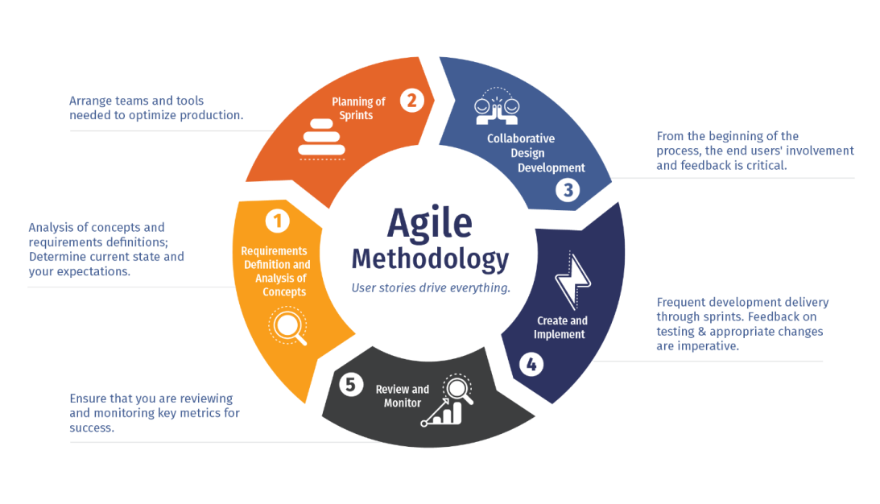Before beginning any project, it is essential to organize it. The roles of the team and the responsibilities of each member must be clearly defined since putting each person

1.1 Agile methodology process

in the appropriate job opens the way for achieving the project's goals. It is the responsibility of the project leaders to assign appropriate tasks to group members and collect completed assignments before the submission date. The project's execution is the collective responsibility of the students. We use a five-phase agile methodology for this project. An agile methodology is a project management practice that boosts a collaborative, iterative, and incremental strategy to project administration. [1]

## 1.3 Project Schedule

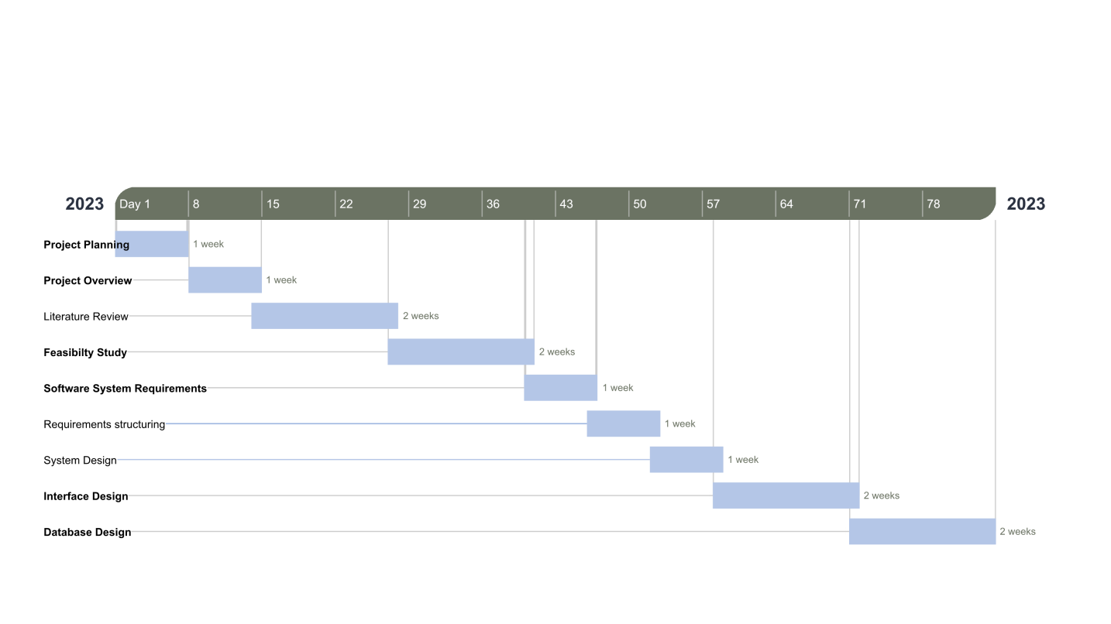

1.2 Gantt chart

## 1.4 Purpose and Overview of this Document

This document's goal is to provide an overview of the procedures and practices we'll use throughout the project development life cycle. This document's major goals are to make it easier for the reader to grasp the phases and to make the project's overall structure clear. The major subjects covered in each chapter of this paper are listed in the section below.

This document contains the following chapters, and each chapter contains specific information in it, which is as follows:

This document contains the following chapters, and each chapter contains specific information in it, which is as follows:

1 - Chapter One

This chapter describes the problem and finds a system to solve it, explaining the project's organizational structure, scope and limitations, the motivation for project selection, and objectives.

2- Chapter Two

This chapter has mentioned a review of some of the literature, a presentation of similar projects, and the advantages and disadvantages of each. It also discusses the main gaps and challenges in the field of study.

3- Chapter Three

This chapter describes the functional and non-functional requirements of the system as well as identifies the people who interact with it. It then presents a use case diagram for the specific users of the proposed system. In addition to clarifying the hardware and software environments, the project needs to explain the features and usability provided to users compared to previous projects, clarify how the user interacts with the application, and define the appropriate architectural strategy and possible plan for project development.

4- Chapter Four

This chapter shows the proposed system with different diagrams such as architecture, class diagram, and activity diagram with the initial interfaces of the application.

5 - Chapter Five

Explain what was accomplished in the entire project and provide the conclusion with cited references that were used and future work for the project.

# Chapter 2 - Literature Review

## 2.1 Introduction:

In this section, we will talk about reviewing the literature, where we will provide an overview of some applications similar to our system, their advantages and disadvantages, compare them with our proposed system, and identify the limitations and problems that these systems face in order to avoid them in our proposed system.

## 2.2 Review of Literature:

The project aims to develop an application that helps university students overcome their problems and difficulties. Students can register, submit a report, view their reports in full detail, and register for a bus. View requests sent to register on the bus, registration status with its details, and all information on the bus after accepting the request, and they can send a request for counseling (psychological - academic) Moreover, display the status of counseling requests sent with all details of the request, display training courses, registration, and display course registration history Download course certificates. Faculty members can also submit a report, view their contacts and details, submit a (professional) consultation request, and view the status of sent consultation requests with all request details. The administrator can also view the communications sent by everyone, respond to an immediate notification, modify the status of the notification to Completed and manage the course: by adding a view to delete, viewing those enrolled in the course, uploading the certificate of those enrolled in the course and many more features that the user can benefit from within the application.

## 2.3 Brief description on Existing System:

**2.3.1 Tuasal**

A Tuasal service that welcomes you and your electronic communication. This service is an easy mechanism for communicating with His Excellency the Minister and officials of the Ministry and all its sectors. This service enables you to put forward proposals or inquiries or express an opinion or advice; To ensure that it is delivered through a practical electronic system, supported by a notification system through electronic services, e-mail, and mobile messages. The electronic service also enables all beneficiaries to track their contributions electronically.

Advantages:

Allows you to submit a suggestion, communication, consultation, or complaint.

Easy to use.

Supports the Arabic language.

Disadvantages:

The app remains hanging immediately after opening.

The website gives an error message when trying to upload.

Does not support English. [1]

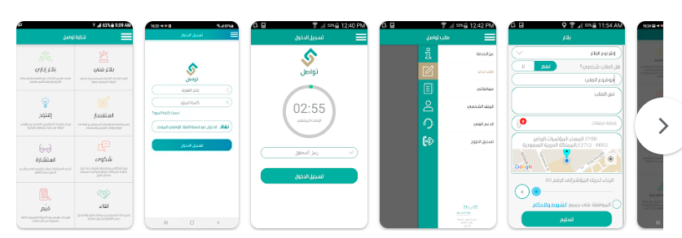

2.1 Tuasal

**2.3.2 Tadribak**

A service provided by the Technical and Vocational Training Corporation to all citizens and residents by allowing the ability to verify the existence of a license for the facilities that provide training, as well as to verify the regularity of the courses of the private training facility. The application also aims to enable citizens and residents to submit reports or observations about the private training facilities or any courses that occur inside or outside the facility.

It is also possible to inquire about reports by the ID number, phone number, or e-mail and to follow up on requests and procedures sent from the branches in detail, and thus benefit from users to contribute to the follow-up of training activities to maintain its safety and quality.

Its advantages:

It contains many courses approved by the Technical and Vocational Training Corporation.

Supports the Arabic language.

Supports different versions.

One of its disadvantages is that it does not support the English language. [2]

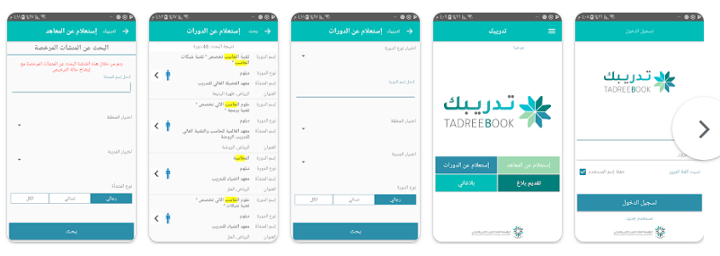

2.2 Tadribak

**2.3.3 MyKKU**

MyKKU application provides a range of services to all employees of King Khalid University, including students, faculty members, employees, and even visitors. Therefore, they can benefit from the application.

Here are some of the app's features:

Academic schedule (for students and faculty members) by displaying your academic schedule during the days of the week.

Request services and technical support from some university departments, such as information technology.

Search for university employees and faculty members and view means of contacting them.

View your profile and edit your profile picture.

Follow announcements and get notifications when there is a new announcement.

Follow the latest events in the University to be aware of all developments, registration, and participation in the various university programs.

Follow up on the University's latest achievements.

A section is dedicated to the University's outstanding employees, showcasing their achievements.

The application contains the university community, a service that allows you to make friends and instant communication with university employees and enables you to create groups for communication.

View your transactions and get notified when there is a new transaction.

GPA Calculator It allows you to know your GPA and use it to predict your future GPA. [3]

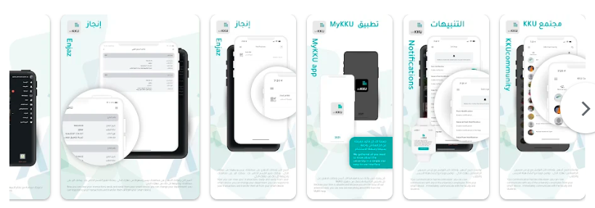

2.3 MyKKU

**2.3.4 Busway**

An application that solves the problems of school transport and delivery companies' problems and enhances students' safety without using any devices or additional costs. Busway makes you reassured by tracking the movement of the school bus for your children quickly and easily, as it is very annoying for the student to wait for the school bus outside the house, for fear that the bus will go without the student knowing his arrival. This may expose the student to problems and dissatisfaction with the school transfer process. Also, the guardian needs to find out when his son boards the school bus when he arrives at school and when he arrives home on the return trip. With Bus Way, the parent, the student, and the school administration can know the actual location of the school bus, communicate directly with the driver, and receive alerts to the guardian of the student boarding the bus and arriving at the school.

Advantages:

The parent or student can record an absence through the application in case they want to avoid going by the school bus for any day of the week.

Real-time tracking service from the Busway application so that the beneficiary can know the school bus's actual location and the student's location after boarding the school bus.

Simple design and ease of use.

With its distinctive tone, the instant notification service informs you of everything that happens to the school bus movement.

With the instant messaging service, the student and the guardian can communicate directly with the school through the application, which provides a unique and effective communication environment.

Disadvantages:

Does not support English.

The application contains ads. [4]

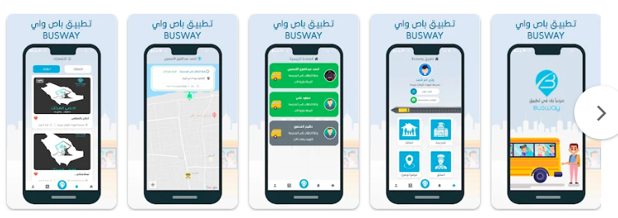

2.4 Busway

## 2.4 Advantages and disadvantages of an Existing system:

##### 2.1 Comparison between the proposed system and similar works

|  |  |  |  |  |  |
| --- | --- | --- | --- | --- | --- |
| System | Provide bus delivery service | Possibility to file a complaint | easy to use | Register for a course | Download course certificates |
| Tuasal | x | √ | √ | x | X |
| Tadribak | x | √ | x | √ | √ |
| MyKKU | x | √ | √ | x | X |
| Busway | √ | x | x | x | X |
| **Proposed system** | √ | √ | √ | √ | √ |

## 2.5 Problems on existing System:

Even with the wide variety of apps currently available, some of them are not particularly suitable for Students at University, especially in the early stages of their educational career, who face many difficulties and challenges, whether related to academic, professional, psychological, or other aspects. For example, on the appropriate means of transportation to reach their places of study, they also need help obtaining a clear career path and training courses that increase their practical experience. Also, faculty members may need help with technical and technological problems that require the consultation and intervention of the technical support employee. Through this project, we will provide Many solutions to those obstacles that students and faculty members face through our proposed system.

Where many of the current applications lack to connect students and provide a suitable solution for them and guide them in the right way, as it lacks many advantages, whether at the level of design, performance or services provided, and this is what will distinguish our application by solving these problems available in the current systems.

## 2.6 Proposed System:

We will develop an application that helps university students overcome their problems and difficulties. Students can register, file a report, view their reports in full detail, and register for a bus. View requests sent for registration in a bus, the registration status with its details, and all bus information after accepting the request, and they can send a request for (psychological) counseling - Academic) Moreover, view the status of the sent consultation requests with all the details of the request, display the training courses and registration, view the registration record in the course, and download the course certificates. Faculty members can also file a report, view their communications and their details, send a (professional) consultation request, and view the status of the consultation requests sent with all Request details. The administrator can also view the communications sent by everyone, respond to an immediate notification, and modify the status of notification to Completed and manage a course: by adding a display of deletion, display of those registered in a course, and raising the certificate of those registered in the course.

The academic advisor can also view the reports sent by everyone and respond to an immediate notification. Modify the status of a report to Completed, present consultation requests in terms of acceptance or rejection, state the reason, respond to a consultation, upload a file, and display the official consultation record.

As for the technical support employee, he can view the reports sent by everyone, respond to an immediate notification, and amend the status of a completion report. As for the bus official, he can view requests to join a bus, accept or reject the request, add a bus, display buses, display the data of those registered in the bus, and print a record. As for the doctor's powers, he can display Consultation requests, acceptance or rejection of the request, state the reason, or respond to the consultation and display a record of consultations accepted by all. Finally, the human resources employee can view consultation requests, respond to a consultation, and display a record of accepted consultations. This is the proposed solution for our system.

## 2.7 Conclusion:

Research and analysis of similar and competing applications of our application helped us to obtain a lot of information about these applications and how they work, and to know the advantages and disadvantages of each. All the information we obtained contributed to building an integrated and clear structure for our application and developed a clear vision of the features and services that the application will provide, and now we are ready to start system design and requirements analysis and developing a plan to build the system.

# Chapter 3 - System Analysis

## 3.1 Overview of Analysis Methodology

The analysis methodology information is organized by analytical function.

The analysis methodology information gives you both in-depth knowledge and best practices for:

* Applying data analysis system functionality
* Applying internal data analysis techniques within a function
* Interpreting data analysis results
* Making decisions or taking actions based on analytical results

## 3.2 System Requirements

The system requirements of Moawen are categorized into two categories which are functional requirements and non-functional requirements. These are the following:

### 3.2.1 Clients, customer and users

* Student: User of the system who can benefit from the application’s services.
* Technical_support: technical support who is responsible for viewing reports and replying to them and changing status
* Bus_offical: bus_offical who is responsible for accepting or refusing register requests and managing buses
* Administrative: administrative who is responsible for managing employees and viewing all consultation
* Cooperator: cooperator who is responsible for viewing student health record, view reports, sending reports, managing consultation requests ( academical, psychological, professional) and managing courses.

### 3.2.2 Functional and data requirements

Functional requirements describe the interaction between the system and the

environment and what the system should be able to do. In the rest of this section,

we are Discussing the functional requirements of the Moawen application in detail.

**Student**

* The application allows students to login into the application.
* The application allows students to update health records
* The application allows students to send reports
* The application allows students to view old reports
* The application allows students to view old details
* The application allows students to bus register
* The application allows students to send request for bus
* The application allows students to view bus info
* The application allows students to view bus register requests
* The application allows students to cancel bus register requests
* The application allows students to send consultation request
* The application allows students to send academic consultation request
* The application allows students to send professional consultation request
* The application allows students to send request for academic / professional consultation
* The application allows students to view files for academic / professional consultation
* The application allows students to view request status for academic / professional consultation
* The application allows students to display courses
* The application allows students to view registered
* The application allows students to register in course
* The application allows students to download certificate

**Technical Support**

* The application allows technical support to login into the application.
* . The application allows technical support to view reports
* The application allows technical support to reply to report
* The application allows technical support to change status to done

**Bus Official**

* The application allows to bus official to login into the application.
* The application allows to bus official to view registered requests
* The application allows to bus official to accept registered requests
* The application allows to bus official to refuse registered requests
* The application allows to bus official to manage buses
* The application allows to bus official to add bus
* The application allows to bus official to view buses
* The application allows to bus official to view registered students data.
* The application allows to bus official to print log

**Administrative**

* The application allows administrative to login into the application.
* The application allows administrative to manage employees
* The application allows administrative to add employee
* The application allows administrative to view employee
* The application allows administrative to block employee
* The application allows administrative to update employee
* The application allows administrative to view all consultation

**Cooperator**

* The application allows to cooperator to login into the application.
* The application allows to cooperator to view student health record
* The application allows to cooperator to view reports
* The application allows to cooperator to reply to report
* The application allows to cooperator to change status to done
* The application allows to cooperator to view old reports
* The application allows to cooperator to send reports
* The application allows to cooperator to view report details
* The application allows to cooperator to send consultation request
* The application allows to cooperator to send request
* The application allows to cooperator to view files
* The application allows to cooperator to view request status
* The application allows to cooperator to manage academicals consultation requests
* The application allows to cooperator to manage psychological consultations requests
* The application allows to cooperator to manage professional consultation requests
* The application allows to cooperator to accept request for (academicals, psychological, professional) consultations
* The application allows to cooperator to refuse request for (academicals, psychological, professional) consultations
* The application allows to cooperator to view accepted requests for (academicals, psychological, professional) consultations
* The application allows to cooperator to reply to request for (academicals, psychological, professional) consultations
* The application allows to cooperator to upload file for a request for (academicals, psychological, professional) consultations
* The application allows to cooperator to manage courses
* The application allows to cooperator to view courses
* The application allows to cooperator to add course
* The application allows to cooperator to delete course
* The application allows to cooperator to view registered students
* The application allows to cooperator to upload certificate

### 3.2.3 Non-functional Requirements

#### 3.2.3.1 Usability requirement

The application should be easy to use and intuitive, with straightforward navigation and a simple interface.

#### 3.2.3.2 Security requirement

The application must adhere to industry-standard security protocols to protect users' data and prevent unauthorized access.

#### 3.2.3.3 Performance requirement

The application should respond to user input within two seconds or less.

#### 3.2.3.4 Portability requirement

The application should be compatible with Android devices and operating systems.

## 3.3 Use Case Diagrams

A use case diagram is a UML diagram used to represent the various scenarios for which a system is designed. Put another way. It represents how a potential user might interact with the system. It illustrates what a system should accomplish, and which user utilizes which functionality, but it ignores implementation specifics like data structure and algorithms [5]

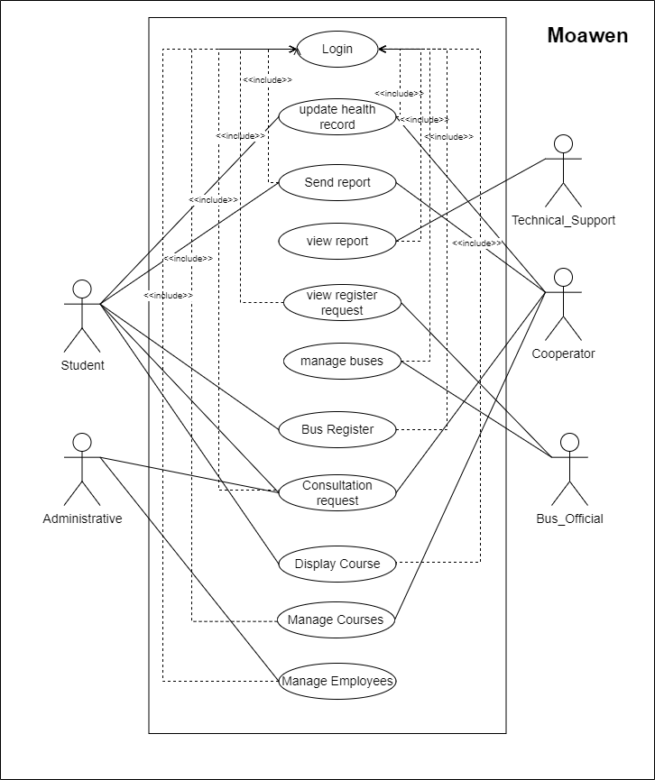

3.1 Full use case diagram

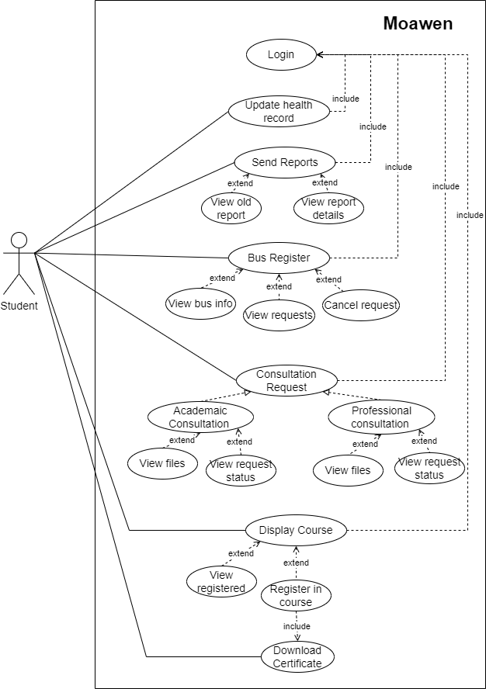

3.2 Student use case diagram

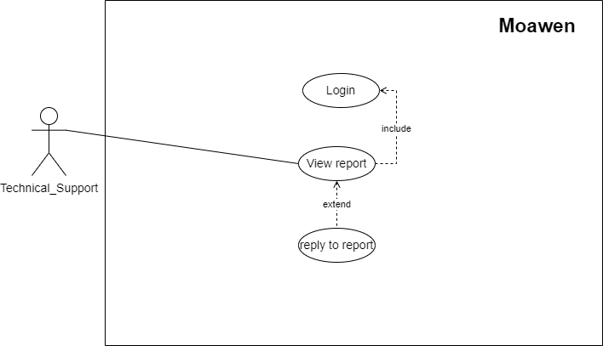

3.3 Technical_Support use case diagram

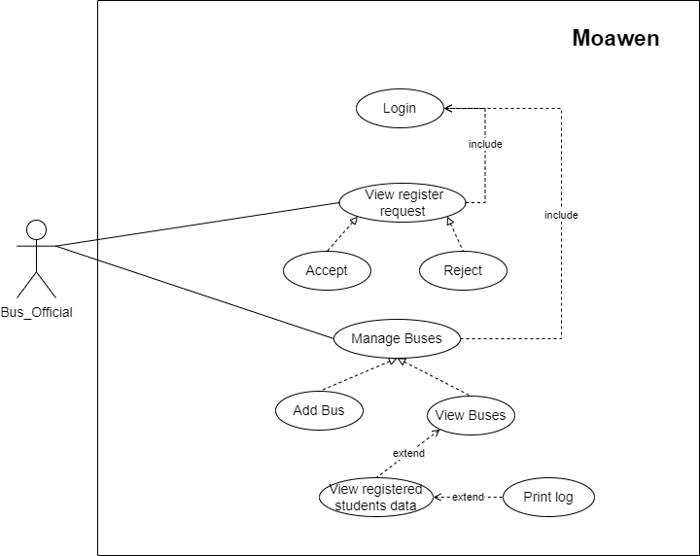

3.4 Bus_offcial use case diagram

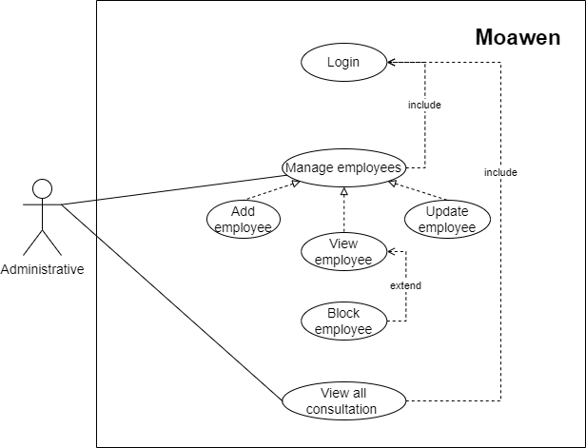

3.5 Administrative use case diagram

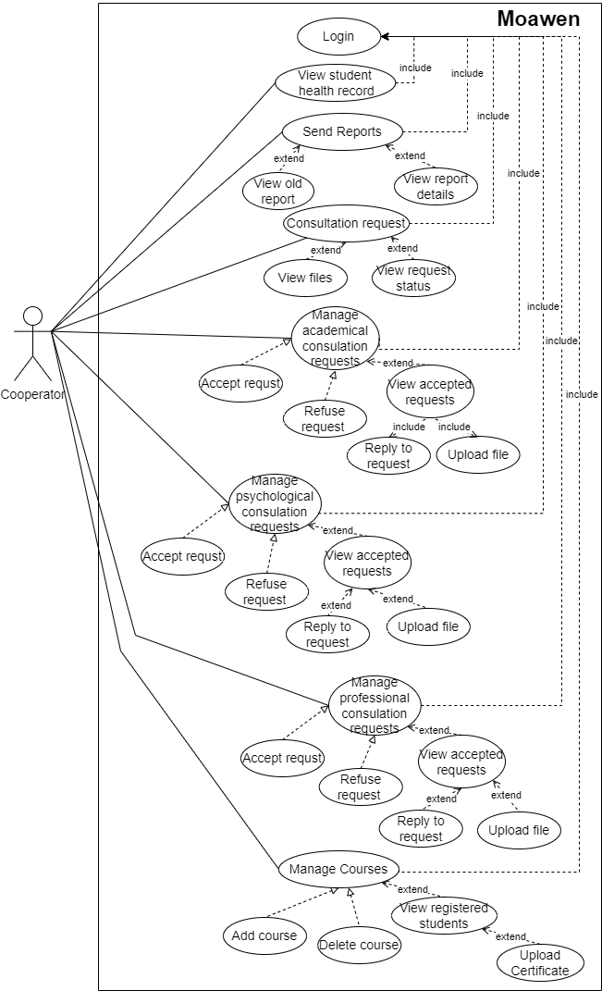

3.6 Cooperator use case diagram

**Textural Description**

##### 3.1 login table

|  |  |
| --- | --- |
| **Title** | Login |
| **Actor** | Student, technical_support, administrative, cooperator |
| **Description** | The user must first login before he can access system activities |
| **Pre-Conditions** | Open the application |
| **Post-Condition** | The user has successfully registered (the e-mail address is confirmed to be unique in the database, all information is correct, and the user accepts the system policies). |

##### 3.2 update health record table

|  |  |
| --- | --- |
| **Title** | Update health record |
| **Actor** | Student |
| **Description** | Student can update his own health record |
| **Pre-Conditions** | Student must be logged in to the system |
| **Post-Condition** | Student updates his own health record |

##### 3.3 view reports table

|  |  |
| --- | --- |
| **Title** | View reports |
| **Actor** | Technical_support |
| **Description** | Technical _support user can view reports and reply to them |
| **Pre-Conditions** | Technical_support user must be logged in to the application |
| **Post-Condition** | Techincal_support user views report and replies to the report |

##### 3.4 view register request

|  |  |
| --- | --- |
| **Title** | View register request |
| **Actor** | Bus_offical |
| **Description** | Bus_offical can accept or refuse register request |
| **Pre-Conditions** | Bus_offical must be logged in to the system |
| **Post-Condition** | Bus_offical views register request and decides either to accept or refuse the request. |

##### 3.5 view all consultation

|  |  |
| --- | --- |
| **Title** | View all consultation |
| **Actor** | Administrative |
| **Description** | Administrative can view all consultation |
| **Pre-Conditions** | administrative must be logged in to the system |
| **Post-Condition** | Administrative views all consultations |

##### 3.6 manage courses

|  |  |
| --- | --- |
| **Title** | Manage courses |
| **Actor** | cooperator |
| **Description** | Cooperator can manage courses |
| **Pre-Conditions** | Cooperator must be logged in to the system |
| **Post-Condition** | Cooperator manages courses with the ability to add a course or delete one, view courses, view registered students and upload certificates. |

# Chapter 4 – Design Considerations

## 4.1 Design Goals and Guidelines

The main objectives of the proposed project are:

* develop an application that helps university students and faculty members to report any problem,
* assist university students and faculty members in requesting various consultations to solve their problems,
* assist university students in obtaining training courses that develop their expertise
* facilitating the educational and technical process for staff
* improving the services provided to students Save time and effort for users.

## 4.2 Operational Environments

### 4.2.1 Hardware Environments

Personal Computer to develop and build the system

### 4.2.2 Software Environment

* Visual Studio Code: To implement the system
* Microsoft office: to build project’s report as well as the presentation
* Draw.io: to prepare the design diagrams for our system
* Canava: Design the poster and interface

### 4.2.3 End User characteristics

The application for user who is a part of Prince Sattam Bin Abdulaziz university college of computer science and engineering for girls therefore who is not a part of the college cannot use the application in which requires ID student to make a register to the system, the application comes with two languages Arabic and English to use the application user should know one of the two language, the application uses android system therefore user should know how to deal with the android system

## 4.3 Architectural Strategies

### 4.3.1 Development Method

We will use the waterfall model for our project, the proses in waterfall model divided Into phases, the waterfall model is an example of a plan-driven process it must plan and schedule all of the process activities before starting work on them, it is a sequential design process in which progress flowing downward (like a waterfall) any phase begins only after the previous phase is complete, the phases are: Requirements, system design, coding, testing and adjustment [4] Here is the advantage that let as use it rather than other models:

1. Allows for management and control, a schedule with deadlines can be set for each stage of development.
2. It is progress in understandable phases and thus it is easy to use.
3. Processing then completing phases one at a time and they do not overlap.
4. Works well in smaller projects where requirements are well understandable [5].SQL Server. PHP can be embedded within a normal HTML web page.

### 4.3.2 Future enhancements/plans

* Improve our system by integrating additional features.
* Implement localization to our system
* Enhance system security level.

# Chapter 5 – System Design

## 5.1 System Architecture and Program Flow

### 5.1.1 Major Modules and Sub Modules

##### 5.1: Major and Sub Modules Table

|  |  |  |
| --- | --- | --- |
| Major Modules | Description | Sub Modules |
| Log In Interface | The interface where users are able to login to the system | * User name field * Password filed * Remember me button * login button |
| Psychological Consoling Interface | The interface where users are able to request psychological consoling | * Question field * Type field * Date field * Time field * Send button |
| Academic Consoling Interface | The interface where users are able to request academic consoling |
| Technical Consoling Interface | The interface where users are able to request technical consoling |  |
| Bus subscription Interface | The interface where users are able to subscribe a bus | * Neighborhood field * Street field * Time_departure field * Time_return field * Request button |
| New course Interface | The interface where users are able to view and register to new courses | A card that contains:   * Image of course * Title of course * Description of course * Course duration * Number of registers * Registration button |
| My courses Interface | The interface where users are able to view registered courses and link to that course | A card that contains:   * Image of course * Title of that course * Duration of course * Number of registers * Link to course button |
| Certificates Interface | The interface where users are able to view and download earned certificates | A list of :   * Course name * Download button |

## 5.2 Detailed Design

### 5.2.1 Class Diagram

A database model shows the logical structure of a database, including the relationships and constraints that determine how data can be stored and accessed. Individual database models are designed based on the rules and concepts of whichever broader data model the designers adopt. An accompanying database diagram can represent most data models. [6]

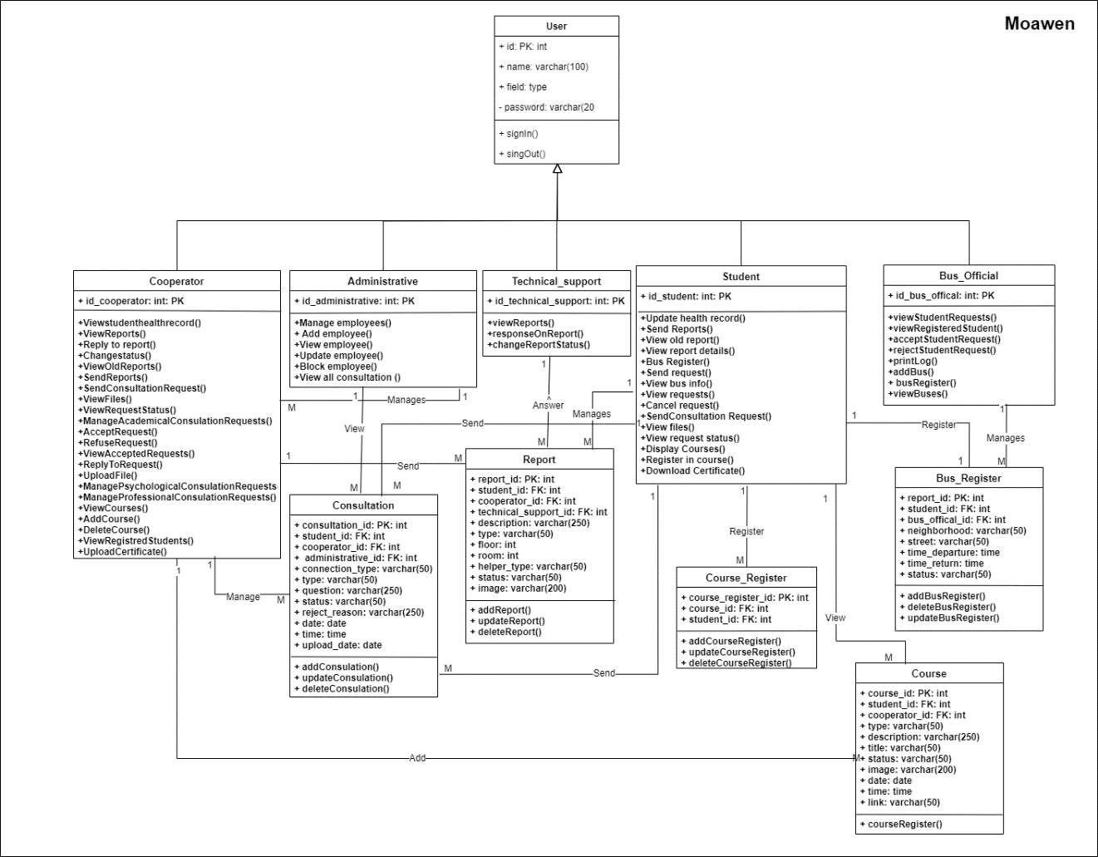

5.1 Database Schema/Class-Diagram

### 5.2.2 Detailed component description

Figure(5.2) shows component diagram description of student dealing with sending reports and updating health record

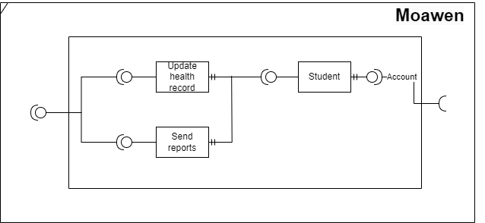

5.2 Component Diagram

### 5.2.3 Dynamic Model Design

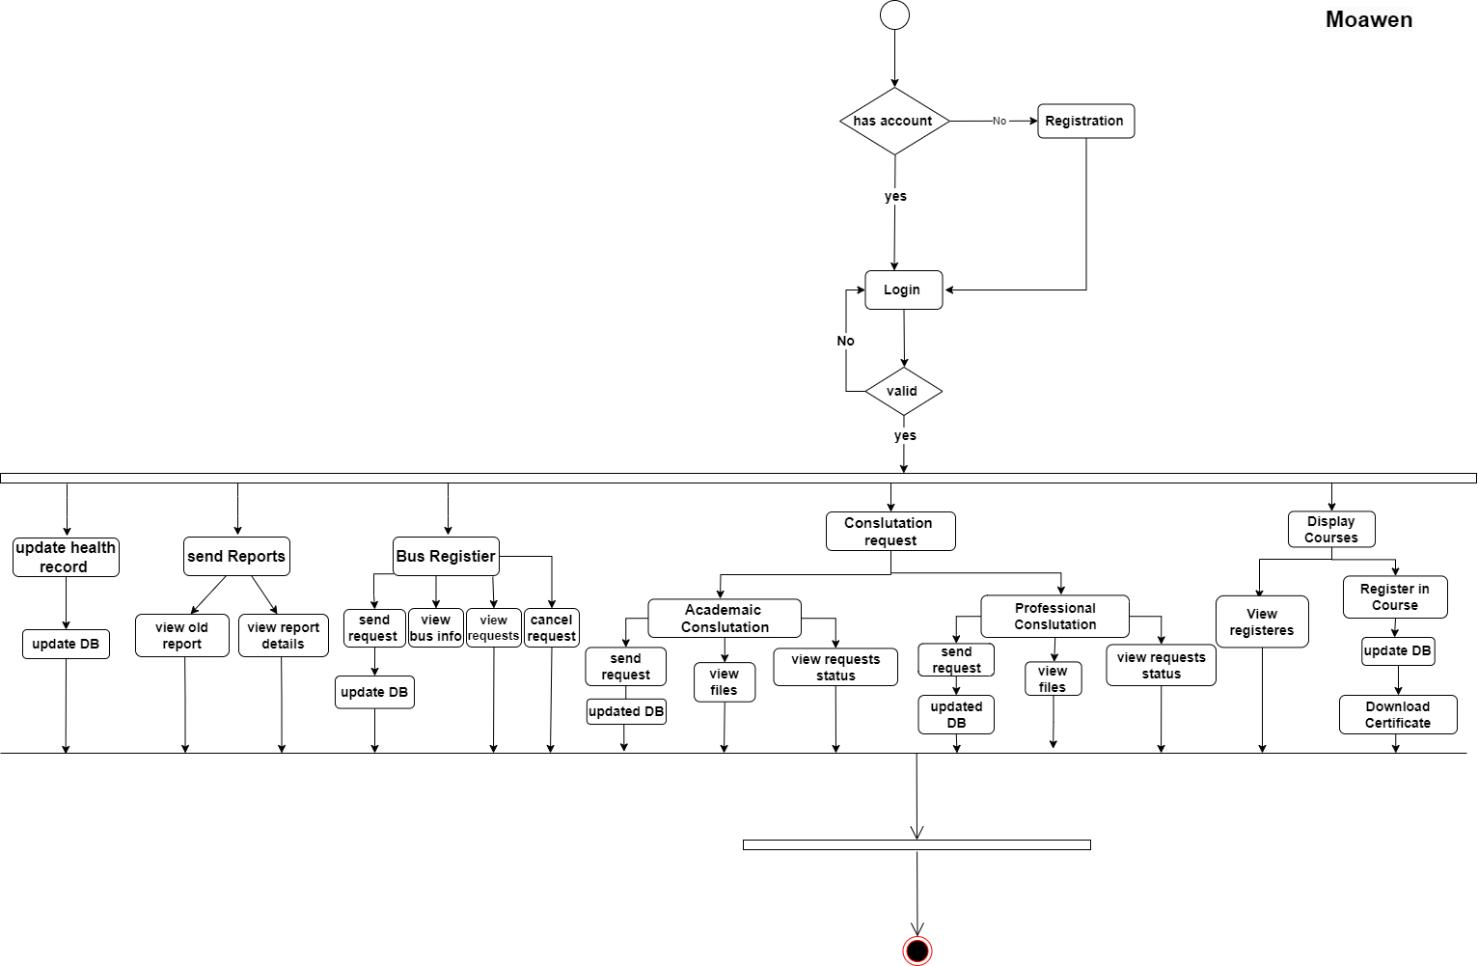Figure(5.3) shows activity diagram for student , in our project , after login to the system, student would be able to update health record, send reports, view old reports, view report details, bus register, send request to register to bus, view bus info, view requests for buses, cancel request for bus, send consultation request ( academic, professional), view files for these consultation, view request status, display courses, view registered courses, register in a course and download a certificate.

5.3 Activity diagram for student

Figure(5.4) shows activity diagram for bus_offical, in our project, after login to the system, bus_offical would be able to view registered requests, accept said request, refuse said request, manage buses, add a bus, view buses, view registered students data and print log.

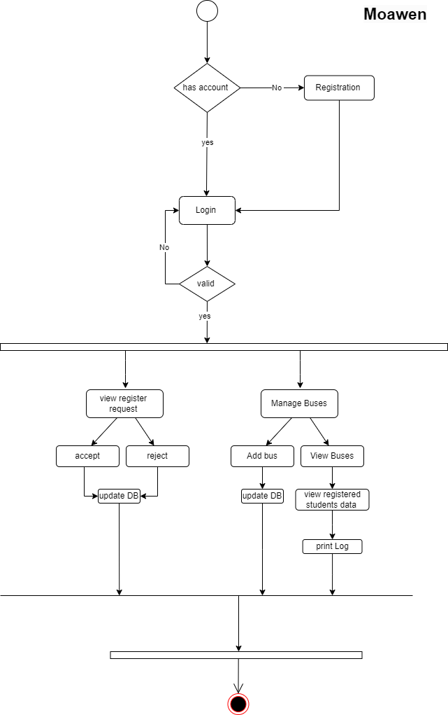

5.4 Activity diagram for bus_offical

Figure(5.5) shows a sequence diagram for student updating his health record, for the student clicks on update health record button to receive update form so that he/she can fill the form after that the form is sent to be validated and new data saved to database, then the updated health record is shown to student.

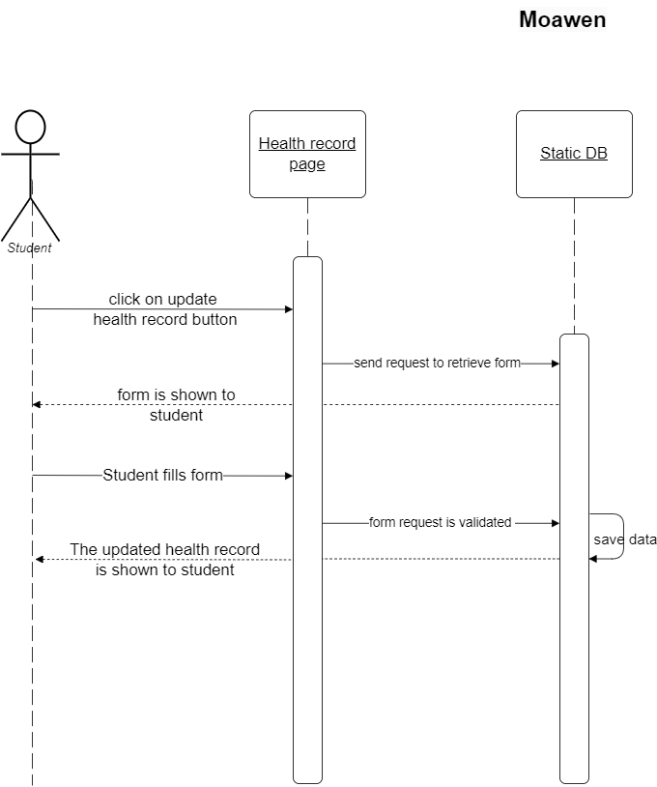

5.5 Sequence diagram for updating health record

### 5.2.4 Initial Interfaces Design

#### 5.2.4.1 Login Interface

Login interface for all system users which contains: email field and password field and remember me button

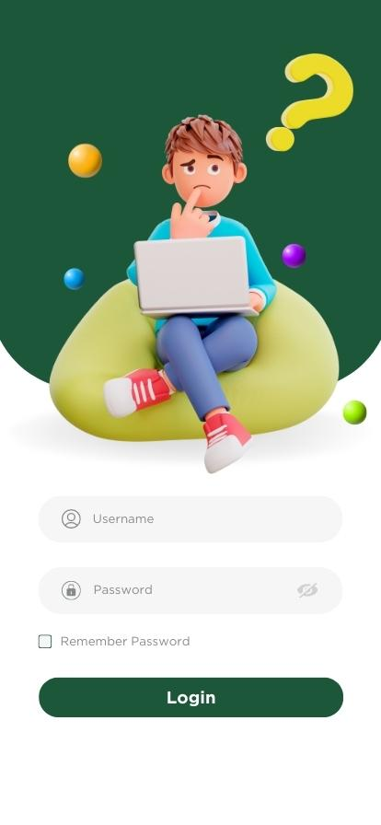

5.6 Login Screen

#### 5.2.4.2 Psychological Counseling Interface

Psychological consoling interface where students would be able to request consoling by filling: question, type, date, time fields.

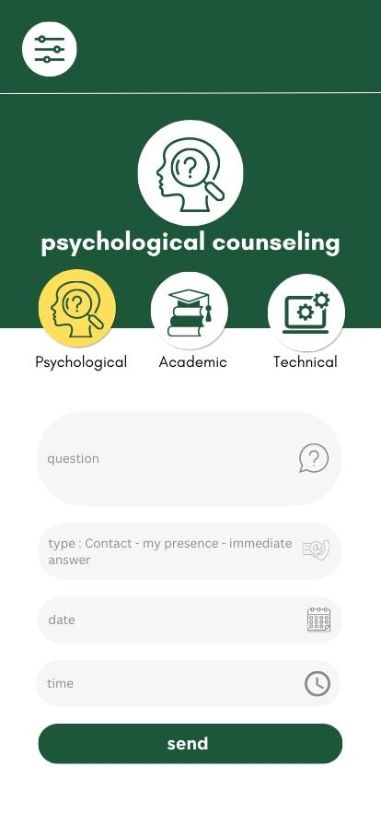

5.7 Psychological counseling screen

#### 5.2.4.3 Academic Counseling Interface

Academic consoling interface where students would be able to request consoling by filling: question, type, date, time fields.

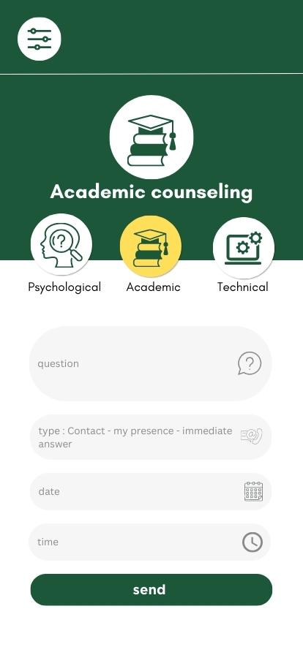

5.8 Academic counseling screen

#### 5.2.4.4 Technical Counseling Interface

Technical consoling interface where students would be able to request consoling by filling: question, type, date, time fields.

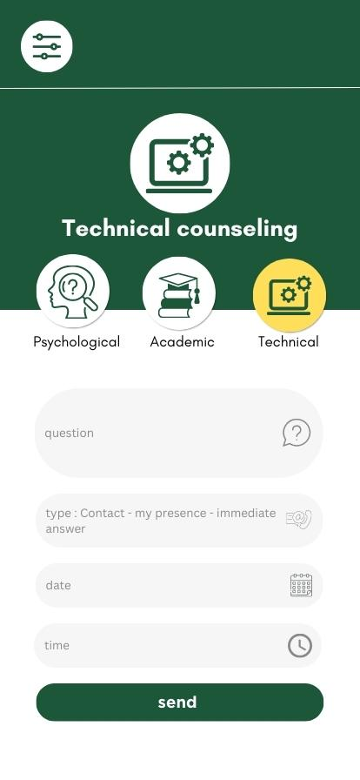

5.9 Technical counseling screen

#### 5.2.4.5 Bus Subscription Interface

Bus subscription interface where students would be able to subscribe to a bus by filling: neighborhood, street, time of departure and time of return.

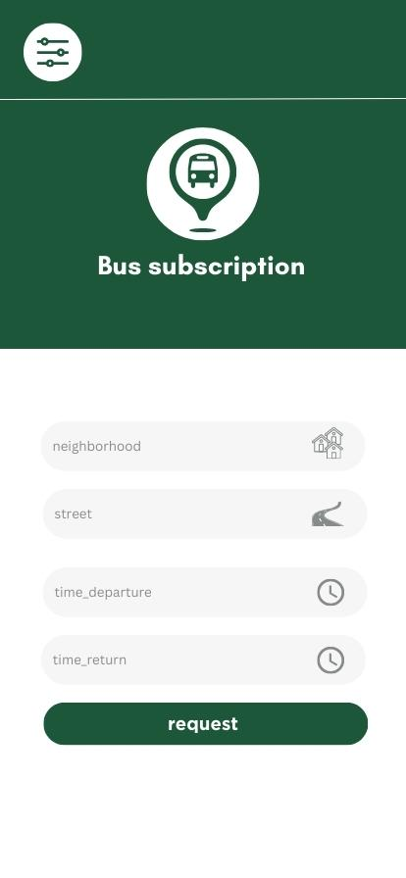

5.10 Bus subscription screen

#### 5.2.4.6 New Courses Interface

New course interface where students would be able to view new courses available in our application

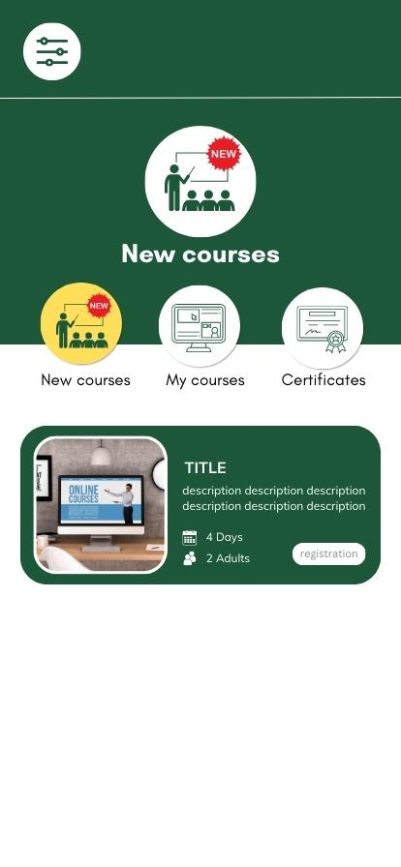

5.11 New courses screen

#### 5.2.4.7 My Courses Interface

My courses interface where students would be able to view their registered courses

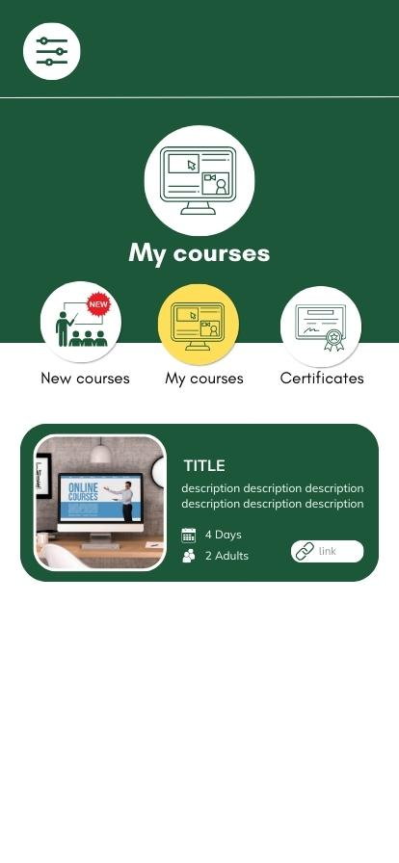

5.12 My courses screen

#### 5.2.4.8 Certificates Interface

Certificates interface where students would be able to download their earned certificates

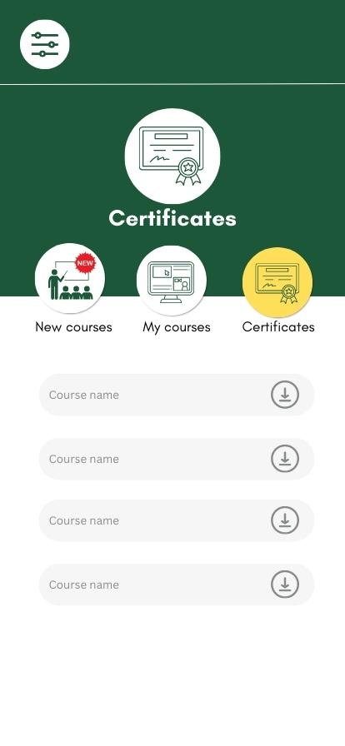

5.13 Certificates screen

## 5.3 Conclusion

In this chapter we discussed the system architecture from the major and sub modules to detailed design of our application which mentioned the class diagram, component description and dynamic model designing.

After that we discussed and shown the initial interface designs

# Chapter 6 - Conclusion

6.1 Conclusion

In this project, we aim to develop an application that helps university students as well as to faculty members to overcome their problems and difficulties by submitting a report, displaying their contacts and details, sending a (professional) consultation request, and displaying the status of sent consultation requests with all request details. The members who are academic advisors can also view reports submitted by students and respond to notifications. The application assures also modifying the report's status to Complete, submitting consultation requests regarding acceptance or rejection, stating the reason, responding to the consultation, uploading a file, and viewing the official consultation record. So this project aims to serve students and faculty members by connecting them with technical support staff and other stakeholders to work on solving any problem they may encounter. In the present document, we discussed the main issues starting from the essential background of the project idea, including the material that motivates us. We then gave an overview of the project techniques we used in the application. After that, we talked about the methodology we carefully chose to develop the project and the advantages and disadvantages of the chosen methodology. Then the document showed the requirements that define the process such as the functional and nonfunctional requirements and specified the functional requirements in UML. After that, we clarified the requirements by designing the project architecture. In the next semester, we will assure the development and testing processes for the application and finally sketch a vision for the future work

# References

|  |  |
| --- | --- |
| [1] | "https://apps.apple.com/sa/app/twasl-wzart-alt-lym/id1071815086," [Online]. [Accessed 18 April 2023]. |
| [2] | "https://play.google.com/store/apps/details?id=gov.tvtc.nedhami," [Online]. [Accessed 18 April 2023]. |
| [3] | "https://play.google.com/store/apps/details?id=sa.edu.kku.myKkuApp," [Online]. [Accessed 18 April 2023]. |
| [4] | "https://play.google.com/store/apps/details?id=com.app.busway&hl=ar&gl=US," [Online]. [Accessed 18 April 2023]. |
| [5] | "uml-use-case-diagram," [Online]. Available: https://www.lucidchart.com/pages/uml-use-case-diagram. [Accessed 13 01 2023]. |
| [6] | "what-is-class-diagram," [Online]. Available: https://www.visual-paradigm.com/guide/uml-unified-modeling-language/what-is-class-diagram/. [Accessed 13 01 2023]. |
| [7] | “Analysis methodology” [Online]. Available: <https://www.ibm.com/docs/en/iis/11.3?topic=practices-analysis-methodology>. [Accessed 13 01 2023]. |